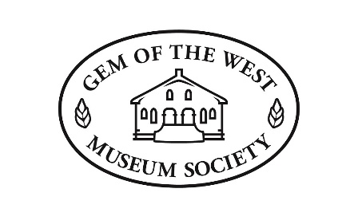

**2025 Summer Employment Job Description**

**Job title:** Museum Assistant

**Job Type:**  Temporary/Student

**Duration:** April 15th – August 30th

**Hours:** 30 hours per week

**Wage:** $18/hour

The Gem of the West Museum Society operates a large rural museum in the old Mennonite Brethren Church owned by the Town of Coaldale. From May to September the museum is open six days a week from 9 a.m. to 4 p.m. on weekdays and 10 a.m. to 4 p.m. on Saturdays.

**Main Duties:**

* Work with the Society Manager and the Collection Management Committee on inputting the museum's backlog of artifacts into the past-perfect database. Proper artifact cataloguing involves researching, labelling, photographing, and storing or displaying artifacts.
* Take on the role of creating a mood board for potential new exhibits. A mood board will contain the layout of the space, what artifacts to display, and researched information that will be presented on wall-mounted boards. It will also contain colour patterns and a cost analysis with potential grants to assist in the cost.
* Assist with other duties and functions as required.
* Except for tours and general walk-in visitors, the student will spend most of the time on these two primary duties.

**Secondary Duties:**

* The Assistant will be scheduled to work Tuesday to Saturday from 9:30 a.m. to 4:30 p.m.
* They will manage the day-to-day operations of the museum, including opening and closing the security gates on each exhibit space, providing tours to individuals, families, or other groups, and assisting with the publication of digital social media content.

**The ideal candidate will:**

* Excel at public speaking and engaging with members of the public
* Possess strong verbal and interpersonal skills
* Be efficient and well-organized
* Be able to work well independently with minimal supervision
* Knowledge of digital media
* Knowledge of or being able to learn Microsoft Office programs, WordPress,

and Past Perfect software.

Applicants must meet the eligibility requirements for Canada Summer Jobs.

**Submit resumes in person, by mail, or email to**:

                   Gem of the West Museum Society

                        Box 343

1306 – 20th Street, Coaldale, Alberta

T1M 1M4

(403) 345 1377

[gem@coaldale.ca](mailto:gem@coaldale.ca)